ASSIGNMENT 10
Name:Inchara M S
Usn:Eng24cy0028

who and w command:
who command-History:
- An early version of who existed on the CTSS system in 1965, written by Noel Morris.
- Tom Van Vleck later wrote a similar command for the Multics system.
- It then became part of early Unix (Version 1 Unix).
Authors
- The Unix version was developed at AT&T Bell Labs by the original Unix team.
- The GNU version used in Linux (coreutils) was written by Joseph Arceneaux, David MacKenzie, and Michael Stone.

w command:History:
The w command shows who is logged in and what they are doing, along with system load averages.
- According to its manual, w combines functionality from a few other commands: who, uptime (or similar), and ps (to see what users are doing).
- In modern systems, its output typically includes: the current time, how long the system has been up, number of users, load average, plus for each user: terminal, login time, idle time, CPU usage, and the command they are running.

- The version of w used in many Linux / Unix-like systems was almost entirely rewritten by Charles Blake.
- The earlier version (that Blake rewrote) was by Larry Greenfield and Michael K. Johnson.
- It’s very handy for a quick snapshot: not only who is logged in (like who), but also what processes they’re running and how busy the system is.
- Over time, as Unix-like systems evolved with richer process accounting and terminal-tracking, w became more useful because it aggregates data.

The who command shows who is currently logged into the system. It first appeared in early Unix systems, influenced by work on CTSS and Multics in the 1960s. Versions for Unix were developed at AT&T Bell Laboratories, and the GNU implementation was later written by Joseph Arceneaux, David MacKenzie, and Michael Stone.
The w command shows who is logged in and what they are doing, along with system load averages. It combines features from commands like who, uptime, and ps. Early versions were by Larry Greenfield and Michael K. Johnson, and the modern Linux version was largely rewritten by Charles Blake.
Both commands evolved to give users information about logged-in users and system activity, with w providing a more detailed snapshot.
Useful for system Administration:
The who and w commands are useful for system administration because they give quick insight into user activity and system load, which are essential for monitoring, troubleshooting, and security.
who command
- Shows which users are currently logged in, including terminal, login time, and host.
- Helps administrators track user sessions and detect unauthorized logins.
- Useful for auditing and managing multi-user systems.
W command
- Shows all logged-in users, what processes they are running, their idle time, and overall system load.
- Provides a more detailed view than who, helping administrators see not just who is logged in but what they are doing.
- Useful for monitoring system performance, identifying resource-intensive processes, and detecting suspicious activity.
WORKING:
who command:
The who command reads the /var/run/utmp file (or /run/utmp on some systems), which keeps track of all current logins. It lists users currently logged in, their terminal, login time, and sometimes the host they logged in from.
Example:
who
output:
inchara pts/0 2025-11-23 23:05 (192.168.1.10)
root tty1 2025-11-23 22:30
Reason: inchara is logged in on pseudo-terminal pts/0 since 23:05 from IP 192.168.1.10.
root is logged in on tty1 since 22:30 (local console).
Other options:
who -b # Shows last system boot time
who -q # Quick list of logged-in users
who -u # Shows idle time for each user
w command:
The w command reads /var/run/utmp to get logged-in users and queries the system for each user’s active processes (usually via /proc filesystem). It also shows load averages and system uptime.
Example:
w
output:
23:15:05 up 2:15, 2 users, load average: 0.15, 0.10, 0.05
USER TTY FROM LOGIN@ IDLE JCPU PCPU WHAT
inchara pts/0 192.168.1.10 23:05 5:00 0.10s 0.10s bash
root tty1 - 22:30 10:00 0.20s 0.20s top
Reason: Shows system uptime (up 2:15), number of users (2 users), and load averages.Lists each user, their terminal, login time, idle time, CPU usage by all processes of the user (JCPU), CPU usage of current process (PCPU), and the command currently running (WHAT).
Other options:
w -h # Hide header
w -s # Short output, minimal info
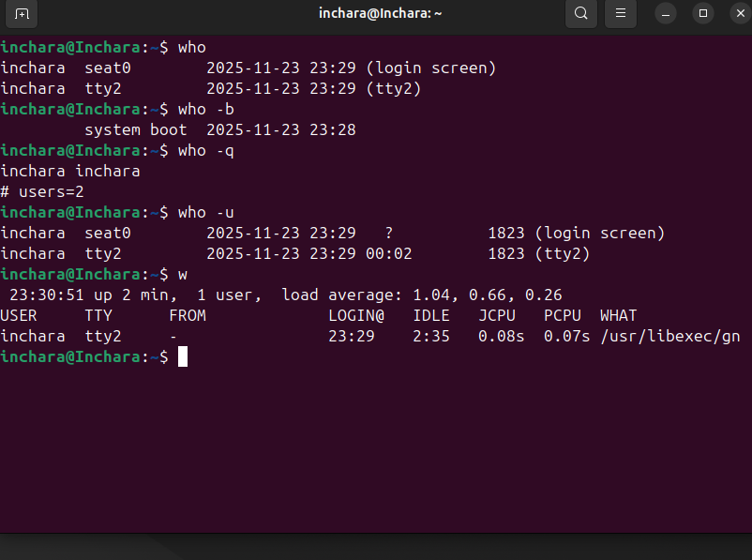
who command: important options / flags
- -a / --all
Shows all available information: combines several flags such as -b, -d, -l, -p, -r, -t, -T, -u.
- -b / --boot
Displays the time when the system was last booted.
- -d / --dead
Prints “dead” (zombie) processes.
- -H / --heading
Prints column headings for the output (like “NAME“, “LINE“, “TIME”, etc.) to make it more readable.
- -q / --count
Shows only the usernames of logged-in users, plus a count of how many users are logged in.
w command: important options / flags
- -h / --no-header
Suppresses the header line (which normally shows system time, uptime, number of users, load average).
- -u / --no-current
Ignores the “current process” when calculating CPU times (JCPU / PCPU); useful if you don’t want the command you’re running (or that someone else is running) to skew those times.
- -s / --short
Short format: hides the LOGIN@, JCPU, PCPU, and WHAT (current process) columns.
- -f / --from
Toggles the “FROM” (remote host) field. By default, w shows the host from which the user logged in; this option can hide or show it depending on implementation.
- -o / --old-style
Uses an old-style output format. For example, idle times less than one minute may be shown differently (blank instead of “0s”) depending on your system version.

Sources / References
- Who command options: Sanfoundry tutorial. Sanfoundry
- Who command flags list + man-page style description. SysTutorials
- W command options: LinuxCommandLibrary. Linux Command Library
- More on w from its man page. manpagez.com

